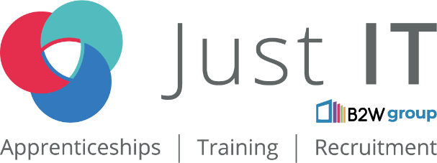

Data Technician

Name:
Course Date:
Table of contents
Day 1: Task 1 3
Day 1: Task 2 3
Day 1: Task 3 4
Day 2: Task 1 5
Day 3: Task 1 9
Day 3: Task 2 10
Day 3: Task 3 11
Day 4: Task 1 12
Day 4: Task 2 13
1. Scenario Background 13
2. Data Laws and Regulations 14
3. Azure Service Recommendations 14
4. Data Types and Data Modelling 14
5. Data Storage Formats and Structures in Azure 14
6. Additional Considerations 15
Submission Guidelines: 15
Course Notes 17
Additional Information 17

Day 1: Task 1

Please research and complete the below questions relating to key concepts of cloud.

Be prepared to discuss the below in the group following this task.

What can cloud computing do for us in the real-world? | Cloud computing can help us access multiple online services without actually buying the hardware. We can use file storage (iCloud, one drive), online gaming, streaming(amazon, YouTube, Netflix) and software as a service (MS Office 365) applications.
How can it benefit a business? | Businesses can benefit by cost savings (not having to buy actual hardware), scalability (adapt to clientele) and flexibility for operations like data backup, disaster recovery, software development and big data analytics in advanced and real-time basis. Also, can benefit by built-in integration protocols for Business Intelligence tools like Power BI, Tableau etc.
What’s the alternative to cloud computing? | - Local Data Storage  - Edge Computing  - On-Premises Servers  - Hybrid computing
What cloud providers can we use, what are their features and functions? | - Amazon Web Services: Object & Block Storage, Manage relational databases, Offers managed Machine Learning platform  - Microsoft Azure: Same as Amazon but also offers NoSQL database on global scale  - Google Cloud: Object & block storage, Powerful data warehousing.

Day 1: Task 2

Please research the below cloud offerings, explain what they are and examples of use cases.

Cloud Offerings | Explain what it is | When / how might you use this service in the real-world?
IaaS (Infrastructure as a service) | IaaS (Infrastructure as a Service) is a form of cloud computing that provides virtualized computing resources over the internet. Rather than buying and maintaining physical servers and data centres, companies can rent infrastructure components such as:  Virtual machines (VMs),  Storage, Networking resources,  Firewalls and load balancers  This infrastructure is managed by a cloud provider (e.g., Amazon Web Services (AWS), Microsoft Azure, Google Cloud Platform (GCP)), and users can scale it up or down as needed. | Website Hosting:  Companies use IaaS to host websites that require scalable infrastructure. For example, a news website might experience traffic spikes during major events—scaling resources dynamically with IaaS handles these peaks without overprovisioning.
PaaS (Platform as a service) | PaaS is a cloud computing model that provides a ready-made platform for developers to build, test, deploy, and manage applications—without worrying about the underlying infrastructure (like servers, storage, or networking).  PaaS Example:  Web & Mobile App Development  PaaS is ideal for building applications without setting up infrastructure manually.  - Example: A startup uses Google App Engine to develop and deploy a mobile app backend with automatic scaling.  Internal Business Applications  - Companies can quickly build tools for internal use (e.g., dashboards, reporting apps) without relying heavily on IT.  - Example: An HR team builds an employee feedback app using Salesforce Platform (a PaaS tailored for business apps).
SaaS (Software as a service) | SaaS is a cloud computing model where software is delivered over the internet—on-demand, fully managed by a third-party provider.  With SaaS, users access software via a web browser (or app) without installing, maintaining, or updating anything locally. | Email & Communication Tools  Sending/receiving emails, scheduling meetings, video conferencing.  - Examples: Gmail, Outlook 365, Zoom, Slack  Accounting & Invoicing  Small businesses use online accounting tools to manage finances without hiring IT staff.  - Example: QuickBooks Online, Xero

Day 1: Task 3

Please research the below terms and explain what they are, when they would be appropriate and a real-world example of where it could be implemented (i.e. what type of organisation).

Public Cloud | A public cloud is a Cloud Computing Model where computing resources (storage, servers, applications) are owned and operated by third-party service providers (Amazon Web Services, MS Azure). These services are delivered over the internet and to multiple users simultaneously.  These can be used to when:  A company wants to avoid investing into hardware & infrastructure. Also, to support scalability and flexibility when dealing with fluctuating workloads. Ideal for startups, SMEs as it would be classed as operational cost rather than capital expenditure.  Real-World Example:  An e-commerce company could use a public cloud to host its website and manage seasonal traffic spikes (e.g., during Black Friday). Instead of investing in extra servers that may sit idle later, the company can scale resources up or down in the public cloud as demand changes.
Private Cloud | A Private Cloud is a cloud computing environment where the infrastructure is dedicated to a single organisation. It can be hosted on-premises (within the company’s own data centre) or by a third-party provider, most importantly, it’s not shared with other customers.  This can be implemented at:  A company requiring greater control, security and compliance over their data. Also, for businesses with high regulatory requirements like healthcare, banking etc.  Real-World Example:  A hospital or healthcare provider might use a private cloud to store and manage patient records. This ensures compliance with healthcare data protection laws (GDPR) while maintaining full control over sensitive data.
Hybrid Cloud | A Hybrid Cloud is a computing environment that combines both public and private cloud (and sometimes on-premises infrastructure), allowing data and applications to move between them. This gives organisations flexibility: they can keep sensitive workloads in the private cloud while using the public cloud for less critical or highly scalable needs.  An appropriate use would be when:  Businesses want both security and scalability. Ideally, for organisations handling sensitive data but on-need basis can quickly expand resources to cover the demand.  Real-World Example:  A bank could use Hybrid Model.  For example; They could use private cloud to store financial records separately and use public cloud for mobile banking services, customer-based apps.
Community Cloud | A Community Cloud is a cloud infrastructure that is shared by several organisations with similar requirements (e.g., compliance, security, or mission). It’s a middle ground between public and private cloud — resources aren’t open to the general public, but they aren’t dedicated to just one organisation either.  Ideally used:  Where multiple organisations in the same sector need to collaborate and share resources securely whilst complying with strict regulatory protocols. Also, it provides greater control than public cloud but cheaper than private cloud.  Real-World Example:  A group of Government agencies could use a Community Cloud to share citizen data securely. Each agency benefits from shared infrastructure and reduced cost.

Day 2: Task 1

Describe, with examples, the three major areas that the Computer Misuse Act deals with.

Area | Description | Example
Section 1:  Unauthorised Access to Computer Material | - Accessing a computer, file or data without Permission.  - This also includes hacking into someone’s account or using another person’s login credential without consent | - Logging into someone’s email or social media account without their consent.  - Unlawfully obtained password to assess a secure company database.
Section 2:  Unauthorised Access with Intent to Commit or Facilitate Further Offences | - Gaining unauthorised access with the intention of committing another crime — such as fraud or data theft.  - This offence is more serious because it involves criminal intent beyond the access itself. | - Hacking into a bank’s computer system to steal customer details or transfer money.  - Breaking into a database to collect credit card information for fraudulent use.
Section 3:  Unauthorised Modification of Computer Material | - Intentionally changing, deleting, or damaging data or software on a computer without permission.  - This includes spreading viruses, ransomware, or deleting important files. | - Creating and releasing a computer virus that deletes files on infected computers.  - A disgruntled employee deliberately wiping company data or installing malware.

The computer misuse act 1990 is an act where an individual can be criminalised because of computer related offense. Describe three extra powers that the Police and Justice Act 2006 (Computer Misuse) has added.

Description

Look at the below website to answer the questions:
https://www.gov.uk/personal-data-my-employer-can-keep-about-me

Write down three items of data which a company can store about an employee.

Give three more examples of data that an employer can only store if they first get the employee’s permission.

Conduct further research to answer the below questions.

Question | Answer
Provide one example of: Copyright infringement
Provide one example of: Plagiarism

What are two consequences of copyright infringement and software piracy?
Give three possible consequences for individuals when using pirated software

Listed below are some laws which we have covered today:

1. Computer Misuse Act 1990
2. Police and Justice Act 2006 (Computer Misuse)
3. Copyright, Designs and Patents Act 1988
4. Copyright (Computer Programs) Regulations 1992
5. The Health and Safety (Display Screen Equipment) Regulations 1992
6. Data Protection Act 2018
7. Consumer Rights Act 2015

- Insert a number in the first column of each row to match each of the statements with one of the above Acts.

- One of statements is incorrect and not illegal. For this statement, write ‘Not illegal’.

Act number | Clause
 | With some exceptions, it is illegal to use unlicensed software
 | Any product, digital or otherwise, must be fit for the purpose it is supplied for
 | Unauthorised modification of computer material is illegal
 | It is illegal to create or use a hacking tool for penetration testing
 | Personal data may only be used for specified, explicit purposes
 | Employers must provide their computer users with adequate health and safety training for any workstation they work at
 | It is illegal to distribute hacking tools for criminal purposes
 | It is illegal to distribute an illicit recording
 | Personal data may not be kept longer than necessary
 | Gaining unauthorised access to a computer system is illegal
 | Employers must ensure that employees take regular and adequate breaks from looking at their screens
 | It is illegal to prevent or hinder access (e.g. by a denial-of-service attack) to any program or data held in any computer
 | Personal data must be accurate and where necessary kept up to date

Day 3: Task 1

Please complete the below lab (3) ‘Explore relational data in Azure’ and paste evidence of the completed lab in the box provided.

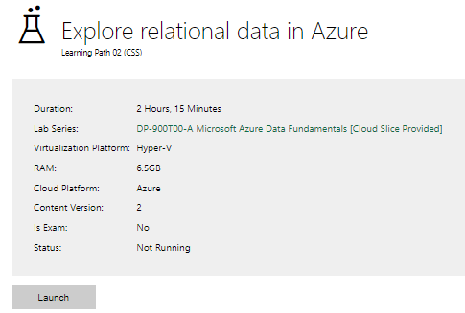

Completed lab | Lab Completed (22nd Oct 2025)

Day 3: Task 2

Please complete the below lab (4) ‘Explore non-relational data in Azure’ and paste evidence of the completed lab in the box provided.

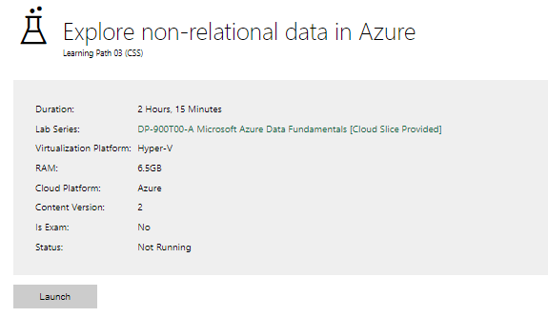

Completed lab | Lab Completed (22nd Oct 2025)

Day 3: Task 3

Please complete the below lab (5) ‘Explore data analytics in Azure’ and paste evidence of the completed lab in the box provided.

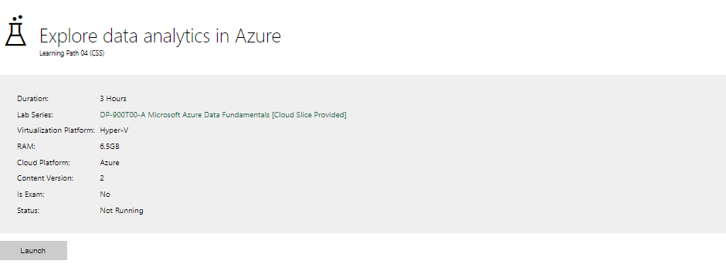

Completed lab | Lab Completed (17:14 on 22nd Oct 2025)

Day 4: Task 1

In your teams, complete the Azure DP-900 practice exam and paste your result below – this is open book and please research and discuss your answers as a team.

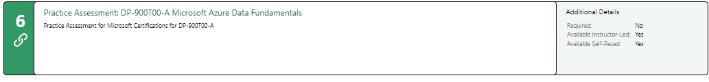
Result | 72%

Day 4: Task 2

1. Scenario Background
"Paws & Whiskers" is a growing pet shop that aims to improve its business by analysing sales, customer information, and inventory data. Currently, the data is collected manually or stored in spreadsheets. Management is interested in transitioning to Microsoft Azure to streamline data storage, analysis, and reporting, enabling them to make data-driven decisions.

2. Data Laws and Regulations
Identify and explain the data laws and regulations relevant to handling customer data within the proposal. Ensure you cover the following points:
- GDPR Compliance: Highlight the importance of adhering to the General Data Protection Regulation (GDPR), particularly as it relates to storing and processing customer information.
- Data Protection Act (DPA) 2018: Outline how the DPA 2018 may affect the way "Paws & Whiskers" collects and stores data, ensuring compliance with UK laws on data privacy.
- Other Industry Standards: Research any additional data protection standards or regulations that may apply to pet shop data, particularly if they involve sensitive or payment information.

3. Azure Service Recommendations
Recommend Microsoft Azure services that would suit the company’s data analysis needs and explain why these services are suitable. Your recommendations should include:
- Data Storage: Identify suitable storage options, such as Azure Blob Storage or Azure SQL Database, and discuss the benefits of each for storing large datasets, including inventory, sales transactions, and customer details.
- Data Analysis Tools: Recommend tools such as Azure Machine Learning for customer behaviour analysis or Azure Synapse Analytics for analysing sales trends.
- Data Integration and Automation: Explain how services like Azure Data Factory could automate data collection and integration processes, improving efficiency.

4. Data Types and Data Modelling
Define the types of data "Paws & Whiskers" will need to work with and describe your approach to data modelling:
- Data Categories: Identify key data types, such as customer demographics, transaction history, pet inventory, and product categories.
- Data Modelling Approach: Outline how you would structure this data using a relational model or a data warehouse approach, considering factors like tables, entities, relationships, and primary keys.

5. Data Storage Formats and Structures in Azure
Discuss how you would store data within Azure and the formats you would recommend:
- Data Formats: Specify recommended formats (e.g., CSV for raw data imports, JSON for structured data, Parquet for analytics) and explain why these formats are suitable for specific data types.
- Data Security and Encryption: Include recommendations for securing data using Azure’s built-in encryption features and access controls to ensure compliance with data privacy regulations.

6. Additional Considerations
Provide any other considerations that might enhance data handling and efficiency in Azure, such as:
- Backup and Disaster Recovery: Outline a backup plan using Azure Backup or Azure Site Recovery to safeguard against data loss.
- Data Visualisation: Discuss potential use of Power BI within Azure for creating dashboards that provide management with real-time insights into sales and customer trends.
- Future Scalability: Comment on how Azure services can scale as the business grows, accommodating larger datasets and more complex analyses.

Submission Guidelines:
- Structure: Ensure your report is well-organised, with sections for each task (e.g., Data Laws, Azure Services, Data Types, etc.).
- Formatting: Include headings, bullet points where appropriate, and any visuals or diagrams that support your explanations.
- References: Cite any resources or regulations referenced in the report.
- Length: Aim for 1500-2000 words.

Focus only on
Azure Service Recommendations
Data Types and Data Modelling
Data Migration

Azure Data Management Proposal for Paws & Whiskers Pet Shop

Executive Summary
This report presents a comprehensive proposal for transitioning Paws & Whiskers pet shop from manual data collection and spreadsheet-based systems to a cloud-based data management solution using Microsoft Azure. The proposal addresses regulatory compliance, recommends appropriate Azure services, outlines data modelling approaches, details the migration strategy, and provides strategic considerations for implementation and future growth.

1. Data Laws and Regulations

1.1 GDPR Compliance
The General Data Protection Regulation (GDPR) is the primary regulatory framework governing how Paws & Whiskers must handle customer data. As a UK business potentially serving EU customers, GDPR compliance is mandatory.
Key GDPR principles include lawfulness and transparency in data collection, purpose limitation ensuring data is used only for specified purposes, data minimization collecting only essential information, and accuracy with appropriate retention periods. Customer data must be secured through robust measures, and the business must demonstrate accountability through documentation and privacy policies. Customers possess rights including data access, rectification, erasure, portability, and objection to processing, requiring Paws & Whiskers to establish efficient procedures for facilitating these rights.

1.2 Data Protection Act 2018
The Data Protection Act 2018 is the UK's implementation of GDPR, providing the legal framework post-Brexit. For Paws & Whiskers, this requires registration with the Information Commissioner's Office, designation of data protection responsibilities, and adherence to lawful processing bases including contract performance and legitimate interests for customer relationship management.

1.3 Additional Industry Standards
PCI DSS (Payment Card Industry Data Security Standard) is mandatory if processing card payments, requiring secure handling of cardholder data through encryption, restricted access, and regular security testing. Azure services offer PCI DSS compliant environments simplifying compliance. The UK Consumer Rights Act 2015 affects transaction and product data retention requirements for supporting returns, refunds, and warranty claims.

2. Azure Service Recommendations

2.1 Data Storage Solutions
Azure SQL Database is recommended as the primary storage solution for structured operational data including customer records, transaction history, and inventory management. This fully managed relational database provides automatic backups, built-in high availability, point-in-time restore capabilities, and automatic scaling based on demand. Advanced security features include transparent data encryption, always encrypted columns for sensitive data, and advanced threat protection. The serverless compute tier provides cost-effectiveness for small to medium businesses by automatically pausing during inactive periods.
Azure Blob Storage complements Azure SQL Database for unstructured data such as product images, supplier documentation, and historical archives. Different access tiers (hot, cool, archive) enable cost optimization based on access frequency, with current product images in hot storage and historical compliance records in archive tier.

2.2 Data Analysis Tools
Azure Synapse Analytics combines data warehousing with big data analytics, enabling analysis of sales trends, seasonal patterns, customer purchasing behaviour, and inventory optimization. It processes queries across operational databases and historical archives, providing insights into product performance, customer lifetime value, and inventory turnover rates.
Azure Machine Learning offers advanced analytical capabilities including demand forecasting, customer segmentation, and churn prediction. Automated machine learning features make sophisticated analytics accessible without extensive data science expertise.
Power BI provides the presentation layer, transforming analytical results into interactive dashboards and reports. Direct connections to Azure SQL Database and Synapse Analytics enable real-time visibility into key performance indicators. Management dashboards display daily sales figures, inventory levels, top-selling products, and customer trends. Department-specific dashboards serve inventory managers focusing on stock levels while marketing staff analyse customer segments. Power BI mobile apps enable remote monitoring with alerts for significant events like stock shortages or unusual sales patterns.

2.3 Data Integration and Automation
Azure Data Factory orchestrates data workflows and integration processes, automating extraction from legacy spreadsheets, transformation into appropriate formats, and loading into Azure SQL Database. It handles regular tasks including archiving aging transaction data, aggregating daily sales summaries, and preparing data for analysis.

3. Data Types and Data Modelling

3.1 Data Categories
Paws & Whiskers will work with five distinct data categories: Customer Data (demographics, contact information, preferences requiring GDPR protection), Transaction Data (purchase records, dates, items, quantities, prices, payment methods), Inventory Data (SKUs, descriptions, categories, suppliers, pricing, stock levels, reorder points), Pet Data (species, breeds, ages, specific needs enabling personalized recommendations), and Supplier Data (contact information, catalogues, pricing agreements, delivery schedules).

3.2 Data Modelling Approach
A relational database model using star schema principles balances operational efficiency with analytical capability. The Customers table serves as a dimension table with CustomerID as primary key, containing demographic and contact information. The Pets table links to Customers via CustomerID foreign key. The Products table uses ProductID as primary key including categorization, pricing, and supplier relationships. An Inventory table tracks stock levels with ProductID foreign key. The Transactions fact table forms the analytical core with TransactionID as primary key and foreign keys to CustomerID. A TransactionItems table provides line-item detail with foreign keys to TransactionID and ProductID. This structure supports efficient transactional processing while enabling straightforward analytical queries. The model follows third normal form to eliminate redundancy, with product categories extracted to a separate Categories table.

4. Data Storage Formats and Structures in Azure

4.1 Recommended Data Formats
CSV (Comma-Separated Values) is appropriate for initial data migration from spreadsheets and periodic bulk imports, providing universal compatibility. JSON (JavaScript Object Notation) is recommended for API communications and semi-structured data like product specifications with varying attributes, with Azure SQL Database natively supporting JSON storage. Parquet format offers advantages for analytical workloads including columnar storage for efficient queries, built-in compression reducing costs, and schema preservation. Binary Formats for product images and documents should be stored in native formats (JPEG, PNG, PDF) within Azure Blob Storage with references stored in the relational database.

4.2 Data Security and Encryption
All Azure SQL Databases and Blob Storage implement transparent data encryption at rest, enabled by default. Encryption in transit uses TLS 1.2 or higher for all data transfers. Azure Active Directory integration with Role-Based Access Control implements least-privilege principles, restricting staff access to necessary data only. Column-level encryption through Always Encrypted or Dynamic Data Masking protects sensitive customer contact details. Azure Key Vault manages all encryption keys, providing centralized administration, access logging, and key rotation capabilities.

5. Data Migration Strategy and Implementation

5.1 Migration Approach and Tools
A phased migration approach minimizes business disruption while ensuring data integrity. Phase 1 involves assessing existing data sources, evaluating quality, and documenting volumes. Phase 2 establishes the Azure environment with security policies before data transfer. Phase 3 begins with a pilot migration of non-critical data to validate processes. Phase 4 migrates operational data during low-activity periods with parallel system running. Phase 5 completes cutover after validation confirms accuracy.
Azure Data Factory serves as the primary migration orchestration platform, extracting data from multiple Excel spreadsheets and CSV files simultaneously. Data Factory pipelines handle transformation logic, mapping spreadsheet columns to database schema, converting data types, and applying business rules during migration. Its visual interface simplifies development while built-in monitoring provides visibility into progress.
Azure Database Migration Service provides specialized capabilities for structured data with minimal downtime through continuous synchronization. Azure Storage Explorer facilitates uploading unstructured content like product images to Blob Storage with bulk transfer capabilities. Power Query within Excel assists with pre-migration data cleansing and transformation, allowing business users to standardize formats, remove duplicates, and validate data before migration. Custom Python or PowerShell scripts within Data Factory pipelines handle complex transformations or specialized requirements.

5.2 Data Cleansing and Validation
Spreadsheet data requires preparation before migration. Standardization ensures consistent formatting for customer addresses, phone numbers, and emails. Deduplication identifies and merges duplicate records using matching logic based on customer identifiers, with defined rules for handling conflicts. Validation implements rules checking required fields, valid data types, acceptable ranges, and referential integrity, ensuring every transaction references valid customers and products.
Migration testing includes volume validation confirming record counts match between source and destination, sample data verification comparing representative records field-by-field, business process testing executing typical workflows with migrated data, and performance testing assessing system responsiveness. Rollback procedures maintain complete backups of source data with documented reversion procedures ensuring business continuity if critical issues emerge.

5.3 Training and Change Management
Staff require training on Azure-based systems including data entry procedures, report access, and troubleshooting, conducted shortly before cutover. Comprehensive documentation covering system access, common tasks, and data governance policies supports ongoing operations. Clear support channels must be established for staff encountering issues.

6. Additional Considerations

6.1 Backup and Disaster Recovery
Azure SQL Database provides automated backups with point-in-time restore for up to 35 days. Long-term retention policies should extend monthly backups to seven years for financial records. Geo-redundant replication across multiple UK regions protects against regional failures while maintaining UK data residency for GDPR compliance. A documented disaster recovery plan should define recovery time objectives of four hours and recovery point objectives of one hour, with quarterly testing ensuring effectiveness.

6.2 Future Scalability
Azure's cloud architecture provides inherent scalability. As transaction volumes increase, Azure SQL Database scales compute resources or implements read replicas for query performance. If opening additional locations, the architecture extends seamlessly with centralized databases and local caching. Advanced analytics can evolve to include real-time stream processing with Azure Stream Analytics and sophisticated machine learning for predictive optimization. Azure API Management can expose data securely to third parties, enabling supplier integrations for automated ordering and e-commerce platforms.

Conclusion
Transitioning to Microsoft Azure provides Paws & Whiskers with a comprehensive, scalable, and compliant data management platform. The recommended architecture addresses immediate needs for efficient data storage and analysis while establishing foundations for future growth. The phased migration strategy utilizing Azure Data Factory and supporting tools ensures smooth transition from legacy spreadsheet systems with minimal disruption. By implementing appropriate Azure services with robust security measures and maintaining GDPR and DPA 2018 compliance, Paws & Whiskers can leverage data-driven decision making to enhance business performance and customer satisfaction.

References
- European Commission. (2018). General Data Protection Regulation (GDPR). Available at: https://gdpr.eu/
- UK Government. (2018). Data Protection Act 2018. Available at: https://www.legislation.gov.uk/
- Information Commissioner's Office. (2024). Guide to GDPR. Available at: https://ico.org.uk/
- PCI Security Standards Council. (2024). Payment Card Industry Data Security Standard. Available at: https://www.pcisecuritystandards.org/
- Microsoft Azure. (2024). Azure Data Factory Documentation. Available at: https://docs.microsoft.com/azure/data-factory/
- Microsoft Azure. (2024). Azure Database Migration Service. Available at: https://docs.microsoft.com/azure/dms/
- Microsoft Azure. (2024). Azure Compliance Offerings. Available at: https://azure.microsoft.com/compliance/

Word Count: 1,987 words

Course Notes

It is recommended to take notes from the course, use the space below to do so, or use the revision guide shared with the class:

Additional Information

We have included a range of additional links to further resources and information that you may find useful, these can be found within your revision guide.

END OF WORKBOOK

Please check through your work thoroughly before submitting and update the table of contents if required.

Please send your completed work booklet to your trainer.

